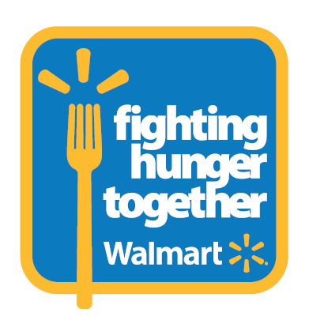

Alaska Resident Secures $50,000 to Help Fight Childhood Hunger through Walmart’s Golden Spark Promotion
Fairbanks resident secures funds for Fairbanks Community Food Bank to sustain local backpack programs

Bentonville, Ark., October 29, 2012 – Through Walmart’s Fighting Hunger Together fall initiative, a resident of Fairbanks, Alaska was randomly selected to win a “Golden Spark” and chose Fairbanks to receive a $50,000 grant from Walmart to help sustain a local backpack program. Today, Walmart awards that $50,000 in grants to the Fairbanks Community Food Bank of Fairbanks, Alaska.

“We are proud of our local community for participating in Walmart’s Golden Spark promotion. Their thoughtfulness has allowed us the opportunity to receive this grant today,” said Samantha Kirstein, Executive Director of the Fairbanks Community Food Bank. “Through this funding, we will be able to provide backpacks filled with food to children in our community when school meals are not available.”

The Fairbanks Community Food Bank backpack program is designed to meet the needs of Fairbanks’s children by providing them with easy to prepare foods to take home during the weekends or holiday vacation when other resources they rely on, such as free or reduced-price school meals, are not available. According to Feeding America, the current child food insecurity rate in Fairbank is 16.8 percent—that’s 4,000 children. With the $50,000 in grants from Walmart, Fairbanks Community Food Bank will be able to provide 500 children in Fairbanks with over 35,000 vital meals for the next three years.

“We are excited by the energy and engagement of our associates and customers in fighting hunger together. These backpack programs will help to provide an estimated two million weekend meals to children across the United States,” said Sylvia Mathews Burwell, president of the Walmart Foundation. “During the past several weeks, we saw an exceptional level of engagement, especially in rural communities where the population may be small, but community spirit is certainly high. By providing unique and creative opportunities for our customers and associates to join the fight against hunger, we hope to make a lasting impact in the local communities that need it most.”

The Fighting Hunger Together fall initiative is part of Walmart and the Walmart Foundation’s $2 billion commitment through 2015 to fight hunger. As a part of this commitment, Walmart and its Foundation pledged to donate more than 1.1 billion pounds of food from Walmart stores, distribution centers and Sam’s Club locations, valued at $1.75 billion, as well as $250 million in grants to support hunger relief organizations. To participate or to learn more about our commitment, visit www.walmart.com/hunger.

About Philanthropy at Walmart
Walmart and the Walmart Foundation are proud to support initiatives that are helping people live better around the globe. In May 2010, Walmart and its Foundation made a historic pledge of $2 billion through 2015 to fight hunger in the U.S. The Walmart Foundation also supports education, workforce development, environmental sustainability, and health and wellness initiatives. To learn more, visit www.walmartfoundation.org.

